# **Name: Abdurrahman Qureshi**

# **Roll No: 210451**

Practical No: 13

1) Python program to create two matrices and perform addition, subtraction, multiplication, and division operations:

CODE:

import numpy as np

matrix1 = np.array([[1, 2, 3],

[4, 5, 6],

[7, 8, 9]])

matrix2 = np.array([[9, 8, 7],

[6, 5, 4],

[3, 2, 1]])

addition_result = np.add(matrix1, matrix2)

print("Matrix Addition:")

print(addition_result)

subtraction_result = np.subtract(matrix1, matrix2)

print("\nMatrix Subtraction:")

print(subtraction_result)

multiplication_result = np.multiply(matrix1, matrix2)

print("\nMatrix Multiplication:")

print(multiplication_result)

division_result = np.divide(matrix1, matrix2)

print("\nMatrix Division:")

print(division_result)

OUTPUT:

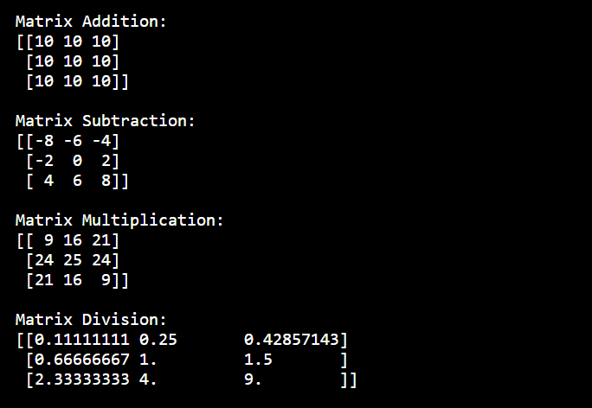

2) Python program to concatenate two strings:

**CODE:**

def concatenate_strings(str1, str2):  
 return str1 + str2  
  
string1 = "I love "  
string2 = "Gym Mommies"  
  
concatenated_string = concatenate_strings(string1, string2)  
  
print(string1)  
print(string2)  
print("Concatenated String:", concatenated_string)

**OUTPUT:**

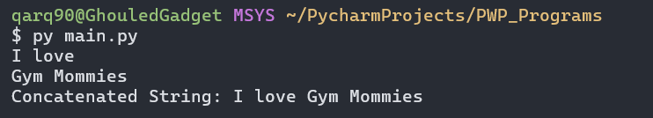

3) NumPy program to generate six random integers between 10 and 30.

**CODE:**

import numpy as np

random_integers = np.random.randint(10, 31, size=6)

print("Six Random Ints between 10 and 30:", random_integers)

**OUTPUT:**



EXTRA QUESTIONS

4) Program demonstrating the use of all string functions.

**Chars.py:**  
def display_student_info(name, roll_number):  
 print("Student Name:", name)  
 print("Roll Number:", roll_number)

**Main.py:**

import my_package.chars as C  
  
C.display_student_info("Spectre",69)

**OUTPUT:**

